Calender Control:

Design View:

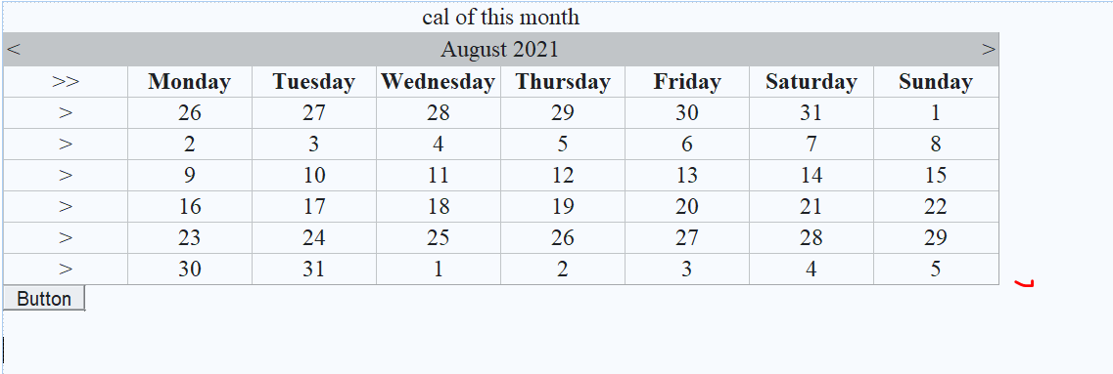

Property Table:

|  |  |  |
| --- | --- | --- |
| Control | Property | Value |
| Calender Control | Caption  DayNameFormat  ShowGridLines  SelectionMode | Cal of this month  Full  True  DayWeekMonth |
| Button | - | - |

Default.aspx.cs

using System;

using System.Collections.Generic;

using System.Linq;

using System.Web;

using System.Web.UI;

using System.Web.UI.WebControls;

public partial class Default2 : System.Web.UI.Page

{

protected void Page_Load(object sender, EventArgs e)

{

}

protected void Calendar1_SelectionChanged(object sender, EventArgs e)

{

}

protected void Button1_Click1(object sender, EventArgs e)

{

DateTime d = DateTime.Now;

Response.Write("<br> selected date:" +Calendar1.SelectedDate);

Response.Write("<br> short date:" + d.ToShortDateString());

Response.Write("<br> long date:" + d.ToLongDateString());

Response.Write("<br> Day:" + d.Day);

Response.Write("<br> month:" + d.Month);

Response.Write("<br> year:" + d.Year);

Response.Write("<br> day of week:" + d.DayOfWeek);

Response.Write("<br> Add days:" + Calendar1.SelectedDate.AddDays(10));

}

}

Demostrate File Upload Control With Example:

Design View:

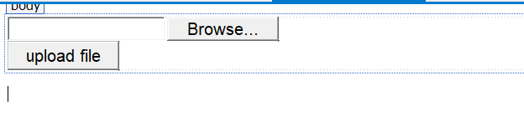

|  |  |  |
| --- | --- | --- |
| Control | Property | Value |
| Button | Text | Upload file |

Default.aspx.cs

using System;

using System.Collections.Generic;

using System.Linq;

using System.Web;

using System.Web.UI;

using System.Web.UI.WebControls;

public partial class Default2 : System.Web.UI.Page

{

protected void Page_Load(object sender, EventArgs e)

{

}

protected void Button1_Click(object sender, EventArgs e)

{

if (FileUpload1.HasFile)

{

Response.Write("file name:" + FileUpload1.FileName);

Response.Write("<br> length:" + FileUpload1.FileBytes.Length);

string fnm = MapPath("img/" + FileUpload1.FileName);

FileUpload1.SaveAs(fnm);

}

else

{

Response.Write("please select file");

}

}

}